IoT-based smart medicine dispenser to control and supervise medication intake

Gleiston GUERRERO-ULLOAa,[1], Miguel J. HORNOS b, Carlos RODRÍGUEZ-DOMINGUEZ b and Ma. Mercedes FERNÁNDEZ a

a Faculty of Engineering Sciences, Quevedo State Technical University, Ecuador

b Software Engineering Department, University of Granada, Spain

**Abstract.** This paper presents a system consisting of a smart medicine dispenser of solid medications (pills, capsules,…) and a mobile application for its configuration and management. The main idea is to offer a solution to help people (especially vulnerable ones) to avoid incorrect medication intakes. In this regard, the smart dispenser delivers the required medication if two conditions are met: (1) it is the scheduled time for a medication intake, and (2) the person who removes the medication from the dispenser (patient or caregiver) can be identified and is authorized to do so. Person identification and authorization is performed through facial recognition by the dispenser and through a username and a password by the mobile application. Moreover, the system reminds the users whenever a medication intake should take place through mobile notifications and lights and sounds emitted by the dispenser. The system development has been guided by a Test-Driven Development Methodology for Internet of Things (IoT)-based Systems to promote its quality and reliability.

**Keywords.** Smart system, medicine dispenser, facial recognition, mobile application, Internet of Things (IoT), elderly

# Introduction

Population ageing is a worldwide concern, due to the system-changing effects that it implies: well-being and social policies, economical sustainability, availability of public services, etc. For example, according to the United Nations [1], 36.81% of the forecasted population (16,062,075 people) will be elderly (over 65 years old) in Spain by 2050. Likewise, 22.35% of the United States of America population (84,813,265 people) will also be elderly by that year.

Nonetheless, life expectancy is steadily growing every year. According to the data published by the European Commission, life expectancy in Europe in 2018 was between 70.1 (Latvia) and 81.9 years old (Switzerland), and has an average growth of 0.3 years per year [2]. That is, it could be roughly in the range between 80 and 92 years old by 2050.

One of the side effects of the population ageing is the widespread impact of many chronic diseases and conditions: diabetes, high blood pressure, heart conditions, cognitive impairment, etc. In that sense, researchers are proposing Internet of Things (IoT)-based systems and smart environments to help elderly people to deal with their consequences [3]–[5]. One of the aids that these systems can offer is to remind and ease medication intakes.

Chronic diseases usually require people to intake many different medications at a very steady schedule. However, due to cognitive decline, elderly people are more prone to intake medications in a wrong way (e.g., more or less intakes than expected, at a different schedule, mix-up medications, etc.) [6]. In fact, according to Singh et al. [7], an estimated 25% of the elderly population does not intake their medication according to the professional prescription. A wrong medication intake can lead to many negative situations, such as health worsening, increased amount of hospitalizations, or even a premature death [8]–[10].

In this paper, we present a system consisting of a smart medicine dispenser and a mobile application for its configuration and management. The dispenser emits a sound and lights up an LED to alert the patient that it is time to take his/her medication. When he/she is close to the smart medicine dispenser, it will identify him/her through facial recognition and deliver the prescribed medication. If the medication is not removed during the expected timings, a notification is sent to the caregiver through the mobile application so that she/he can act consequently. The mobile application can also deliver reminders to those patients able to use a smartphone. This is useful when they are not close to the dispenser at the schedule time for a medication intake. Moreover, it allows registering several patients, as well as managing the medication schedule and even multiple smart dispensers.

The remainder of this paper is structured as follows. Section 2 presents some previous works related to smart medicine dispensers. Section 3 describes the proposed system. Finally, Section 4 outlines our conclusions and future work.

# Related Work

IoT is a lifestyle transforming computing paradigm [11] that can even lead to the fourth industrial revolution [12], [13]. Furthermore, IoT is an opportunity for many researchers to propose smart systems to help people in many domains, among them those that emit reminders to people to assist them during their daily life at home.

For instance, an IoT-based system prototype to offer light, sound and voice reminders to elderly people through a chair is proposed in [6]. Another work with the same goal is presented in [14], but using a photo frame to emit a set of reminders that are previously configured through a mobile application. In both cases, reminders are generic, that is, they do not have a specific goal.

Many other systems are specifically designed to deliver medication-related reminders. However, in a comparison of some existing medicine dispensers [8], the conclusion was that most of the existing proposals do not rely on an Internet connection (i.e., they do not allow remote operation) and do not have any user interaction.

Nonetheless, more recent related works do use Internet. For example, a smart medicine flask that delivers reminders according a pre-established schedule is presented in [15], while a medicine dispenser that delivers medication intake reminders to smartphones is proposed in [16]. Other proposals remind medical intakes through the dispenser using sounds [16][17][18], lights [19][20], or both [21][15]. The smart dispensers proposed in [9], [20], [16], [7], [21] and [15] do not implement person detection to know if the patient is physically close to the dispenser. In [17], patient presence is detected using infrared, and in [22] and [19], using ultrasounds. In [7] and [9], the vital signs of the patient are detected to deliver the medication only when is necessary, although these systems do not emit reminders to users.

The dispenser proposed in [22] is oriented towards autonomous people, since the patient itself must specify the medication and intake schedule, and the patient is responsible of being close to the dispenser at the right timing.

Other works do not guarantee if it is the correct patient who really removes the medication from the dispenser. In [17], [19], the medication can be removed by any person who is close to the dispenser at the right time. Other works [7][22][21] try to identify the user, but the proposed mechanisms are easy to overcome. In [9], fingerprint detection is used to identify the patient, but it requires that the person has enough skills and abilities to interact with the system.

Previous works have motivated us to propose a new smart medicine dispenser that is able to deliver notifications to both dependents (mainly elderly people) and caregivers, automatically provide the prescribed medication on schedule, ensures user authentication and is easy to interact with it. A smartphone application will complement the dispenser operation by allowing remote notifications and its configuration and management.

# Features of the Proposed System

The system we propose is made up of a network of sensors and actuators with a gateway implemented in a Raspberry Pi B single-board computer. These hardware components are integrated with a mobile application that allows the system data management and that provides an intuitive interface to be used by the end users, i.e. the patients and/or their caregivers.

To develop this system, we have followed the Test-Driven Development Methodology for IoT-based Systems (TDDM4IoTS) [4]. As a proof of concept, we have developed a first prototype of the system, which we are currently evaluating with a real patient who is undergoing medical treatment for diabetes. This person must take the medications shown in Table 1, which also details the doses and timetable in which she has to take them.

**Table 1**. Patient treatment medications.

|  |  |  |
| --- | --- | --- |
| Active principle | Doses (mg/day) | Timetable |
| Nateglinide | 60 | 10:00am, 9:00pm |
| Miglitol | 50 | 5:30 pm |
| Acabosa | 50 | 10:30 am, 6:30 pm |
| Repaglinide | 1 | 9:30 am, 2:30 pm |

Given that it would be necessary for more patients and their caregivers to evaluate the developed prototype, it is still too early to guarantee the success of our proposal. Nonetheless, we are optimistic about it, due to the favourable expressions emitted by both the patient and the caregiver who are assessing it.

## System Architecture

The system architecture, which is shown in Figure 1, is similar to the one presented in [5]. Each of its layers is described below.

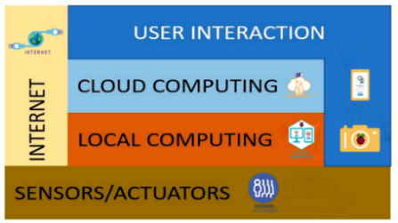

**Figure 1.** System layered architecture.

*Physical Layer*. It is made up of the sensors and actuators that are embedded into the dispenser (more details and photos about it will be provided in the following subsection). As for sensors, it includes an HC-SR501 passive infrared (PIR) sensor and a Raspberry Pi Camera Board v1.3. The former detects close movements and activates the camera used for facial identification, which is located inside a small slot in the central-front-top part of the dispenser. In addition, it integrates four (Tower Pro Micro Servo 9g SG90) servomotors, which are the actuators that push the corresponding medicine box through one of the four compartments that the dispenser has. These servomotors are controlled by an Arduino Uno R3 microcontroller board. Moreover, the dispenser has an LCD screen, a buzzer and 4 LED lights (one for each of its compartments). Every time a medicine box is dispensed, the LED in that compartment lights up and the buzzer emits a sound to alert the user, while the time and the name of the medicines dispensed are displayed in the LCD screen.

*Local Computing*. This layer is in charge of registering patients, detecting their faces and taking the necessary photographs to correctly identify them later on. To do so, a mobile app that detects people’s faces using the Vision library in AndroidStudio is run. Patient identification is carried out using a face identification application developed in Python (version 2.7) with the OpenCV library (version 2.7). This application runs on a Raspberry Pi 3 model B+.

*Cloud Computing*. We use RESTful cloud services for processing, storage and database management (specifically in PostgreSQL, version 10.8). In addition to storing information in the PostgreSQL database, a folder is created for each patient in which we store the photographs that are used for his/her later identification.

*User Interaction*. The dispenser works non-intrusively. Thus, when the PIR sensor detects any movement near the dispenser, the camera is activated to try to identify if the approaching person is a registered patient. In that case, after identifying him/her, if it is time to take some of his/her medicines, they will be dispensed; otherwise, the time of his/her next dose will be shown on the LCD screen. Another way of interacting with the system would be through the mobile app, which will be used mainly by caregivers. Thus, they will be the ones who will enter the system configuration data, as well as their own data and those of the patients in their care, in addition to their doses of medications and the hours in which they must be taken. The mobile app also serves for the caregiver to receive notifications about whether or not the patient has obtained the medications from the dispenser. If the patient is able to use a smartphone, then he/she could also receive reminders about his/her medicine intakes through the mobile app [7][19]. Figure 2 shows some screenshots of the mobile app. The one on the left (A) shows the menu for the caregiver profile. In it, the *Patients* option gives access to the list of patients who are in charge of the caregiver, as shown in the central capture (B), which also allows adding more patients; the *Dispensers* option would show the list of nearby dispensers, being necessary to have the Bluetooth of the smartphone activated so that it can recognize them; and the *Medicine Boxes* option displays the screenshot (C), which shows buttons to manually dispense the medicine boxes that are at the bottom of the corresponding (four) compartments, this option must be used when the patient has not approached the dispenser when he/she should.

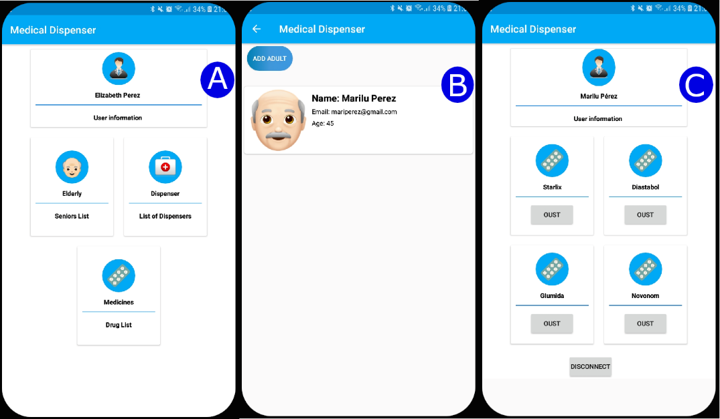

**Figure 2.** Capturas de las pantallas de la aplicación móvil.

*Internet*. This layer is essential for IoT-based systems. In our case, the Internet is used for cloud storage of all information and for remote processing when local devices do not have enough resources. All notifications intended for users are issued from a remote system, being also essential to use the Internet for this.

## Design and Implementation Details

The design of our smart medicine dispenser is shown in Figure 3. In it, we can see the different hardware components that make up of the dispenser. It can be powered either by batteries or connected directly to an electrical supply socket.

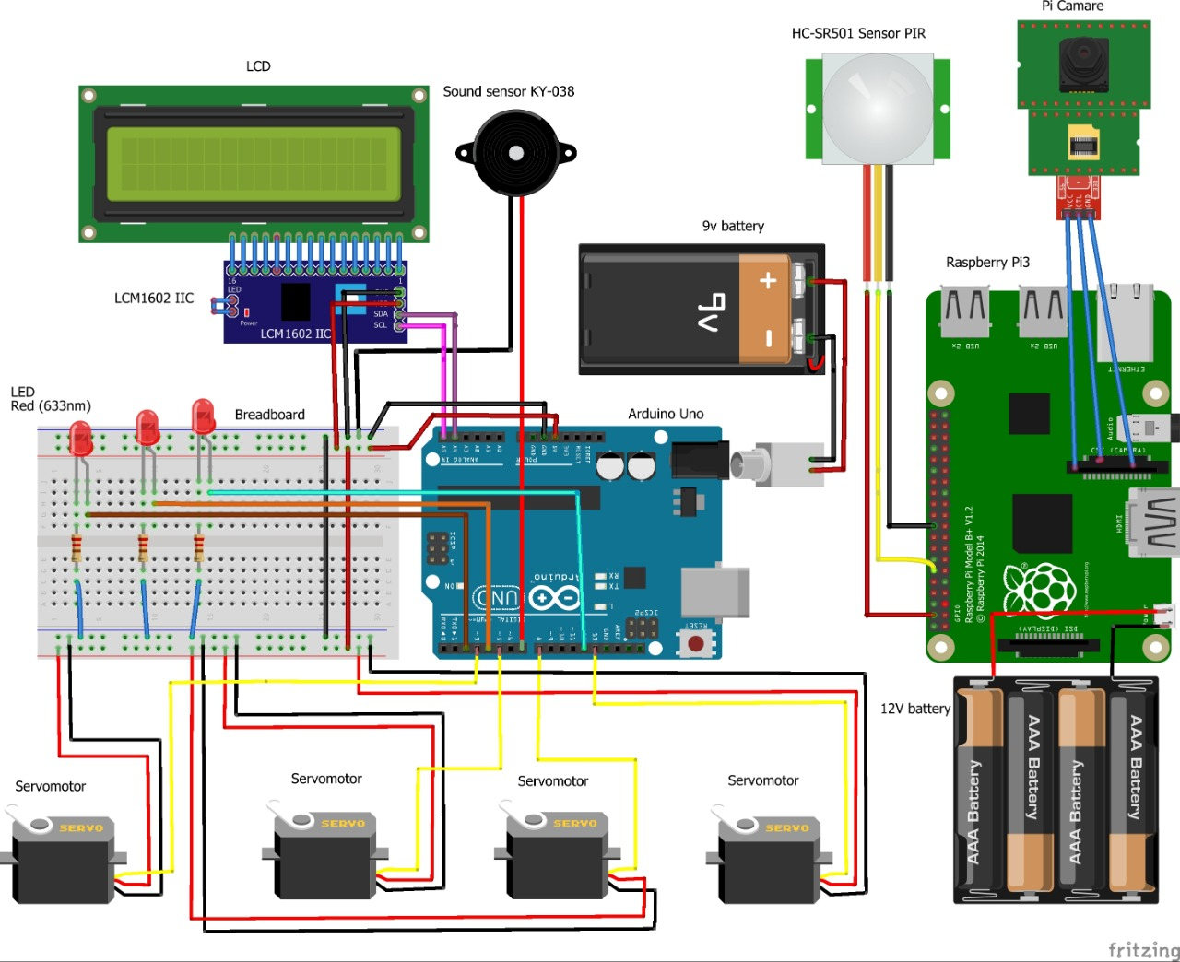

**Figure 3.** Diseño del dispensador de medicinas

The dispenser is developed to supply the solid medications (pills, capsules,...) that each patient needs to take on schedule. The physical model implemented for the dispenser is shown through several photos in Figure 4. The one on the left (A) shows the inside of the dispenser (with the back cover removed), where we can see two shelves: At the bottom one, there are four servomotors, which are in charge of activating a mechanism with a small rectangular piece that will push the medicine box which is at the bottom of the corresponding compartment towards the dispenser tray. At the top shelf, we can see the processing components, i.e., an Arduino Uno R3 and a Raspberry Pi 3 model B+, as well as their connections. The Arduino board controls the servomotors, the Bluetooth module and the LCD screen so that each of these elements fulfils their function, while the Raspberry one manages the facial identification using the camera, as well as the notifications through the LED lights and the sounds emitted by the buzzer. As shown in the top view (B) and in the front view (C) of the dispenser, it has four vertical compartments. In each of them, we can place up to 12 small boxes (48 in total) like the one shown in the photo on the right (D). All the medicines that a patient must take at a certain time should be introduced in one of these boxes (2.5 cm × 2 cm × 1 cm). Each box can have a different colour. Normally, the caregiver will be who put the medicines in each box, and the boxes inside the dispenser compartments. Note that the dispenser could be shared by 4 patients, assigning a different compartment to each patient.

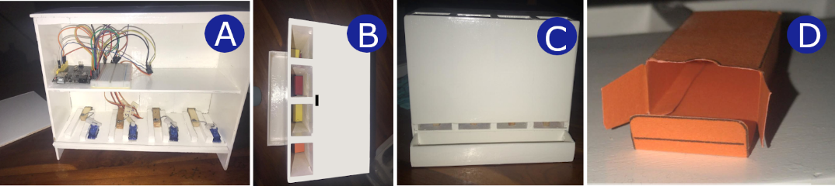

**Figure 4.** Dispensador inteligente de medicinas y la caja para colocar la medicina.

# Conclusions and Future Work

We have presented a smart medicine dispenser that helps older people or people with a cognitive problem to take their medicine doses on schedule. In addition, it allows caregivers to supervise that their dependents take their medications on time. Using a facial identification mechanism, it recognizes the patients registered in the system and supplies them with the medicines they should take just when needed. Every time the dispenser provides a medicine box, it generates a sound and illuminates the corresponding compartment. The system also sends remote notifications to caregivers, informing them of the medicines dispensed to their dependents directly on their smartphone. Thus, they can supervise the correct administration of medications and act when necessary (e.g., when somebody forgets to take a dose). In addition, those patients who can use the mobile app may be notified each time they have to take a dose, so that they approach the dispenser to withdraw it.

As future work, we want to improve the proposed system, closing the dispenser compartments so that they only open when the camera detects the face of the caregiver who must place the medicine boxes in them. This would make it safer. It would also be good for the system to automatically detect which medicines and how many of them the caregiver has put in the different compartments; currently, he/she is who must provide these data through the mobile app. Moreover, an interesting extension would be the automatic request of the necessary medicines to a pharmacy by the system before the patient runs out his/her stock, since this will prevent him/her from losing any intake due to not having a certain medicine. Finally, the dispenser could also be integrated into a more general IoT-based system to help elderly people or people with cognitive problems in their daily life.

# References

[1] UN Department of Economics and Social Affairs, “World Population Prospects - Population Division - United Nations,” *The International Journal of Logistics Management*, 28-Aug-2015. [Online]. Available: https://population.un.org/wpp/Download/Standard/CSV/. [Accessed: 07-Apr-2020].

[2] Eurostat, “Statistics | Eurostat,” *Life expectancy at birth by sex*, 27-Feb-2020. [Online]. Available: https://ec.europa.eu/eurostat/databrowser/view/tps00208/default/table?lang=en. [Accessed: 08-Apr-2020].

[3] B. Baranidharan, “Internet of Things (IoT) Technologies, Architecture, Protocols, Security, and Applications: A Survey,” in *Handbook of Research on Cloud and Fog Computing Infrastructures for Data Science*, P. Raj and A. Raman, Eds. IGI Global, 2018, pp. 149–174.

[4] G. Guerrero-Ulloa, M. J. Hornos, and C. Rodríguez-Domínguez, “TDDM4IoTS: A Test-Driven Development Methodology for Internet of Things (IoT)-Based Systems,” in *Communications in Computer and Information Science*, 2020, vol. 1193 CCIS, pp. 41–55.

[5] G. Guerrero-Ulloa, C. Rodríguez-Domínguez, and M. J. Hornos, “IoT-Based System to Help Care for Dependent Elderly,” in *Communications in Computer and Information Science*, 2019, vol. 895, pp. 41–55.

[6] O. Erazo, G. Guerrero-Ulloa, D. Guzmán, and C. Cáceres, “From a Common Chair to a Device that Issues Reminders to Seniors,” in *Communications in Computer and Information Science*, 2020, vol. 1194 CCIS, pp. 439–448.

[7] U. Singh, A. Sharad, and P. Kumar, “IoMT Based Pill Dispensing System,” in *2019 10th International Conference on Computing, Communication and Networking Technologies, ICCCNT 2019*, 2019, pp. 1–5.

[8] R. Huang, X. Zhao, and J. Ma, “The contours of a human individual model based empathetic u-pillbox system for humanistic geriatric healthcare,” *Futur. Gener. Comput. Syst.*, vol. 37, pp. 404–416, 2014.

[9] S. Jaipriya, R. Aishwarya, N. B. Akash, and A. P. Jeyadevi, “An intelligent medical box remotely controlled by doctor,” in *Proceedings of the International Conference on Intelligent Sustainable Systems, ICISS 2019*, 2019, pp. 565–569.

[10] G. Schreier, M. Schwarz, R. Modre-Osprian, P. Kastner, D. Scherr, and F. Fruhwald, “Design and evaluation of a multimodal mHealth based medication management system for patient self administration,” in *Proceedings of the Annual International Conference of the IEEE Engineering in Medicine and Biology Society, EMBS*, 2013, pp. 7270–7273.

[11] L. Atzori, A. Iera, and G. Morabito, “The Internet Of Things: A Survey,” *Comput. Networks*, vol. 54, no. 15, pp. 2787–2805, Oct. 2010.

[12] C. Salkin, M. Oner, A. Ustundag, and E. Cevikcan, “A Conceptual Framework for Industry 4.0,” in *Industry 4.0: Managing The Digital Transformation*, A. Ustundag and E. Cevikcan, Eds. Springer, Cham, 2018, pp. 3–23.

[13] H. Xu, W. Yu, D. Griffith, and N. Golmie, “A Survey On Industrial Internet Of Things: A Cyber-Physical Systems Perspective,” *IEEE Access*, vol. 6. pp. 78238–78259, 2018.

[14] O. Erazo, R. Santana, and G. Guerrero-Ulloa, “A Ubiquitous Photo Frame To Provide Reminders To Older Adults,” Jan. 2019.

[15] P. K. Nijiya Jabin Najeeb, A. Rimna, K. P. Safa, M. Silvana, and T. K. Adarsh, “Pill care-the smart pill box with remind, authenticate and confirmation function,” in *2018 International Conference on Emerging Trends and Innovations In Engineering And Technological Research, ICETIETR 2018*, 2018, pp. 1–5.

[16] S. B. Kumar, W. W. Goh, and S. Balakrishnan, “Smart Medicine Reminder Device For The Elderly,” in *Proceedings - 2018 4th International Conference on Advances in Computing, Communication and Automation, ICACCA 2018*, 2018, pp. 1–6.

[17] A. Jabeena and S. Kumar, “Smart medicine dispenser,” in *Proceedings of the International Conference on Smart Systems and Inventive Technology, ICSSIT 2018*, 2018, pp. 410–414.

[18] R. I. Rumi, M. I. Pavel, E. Islam, M. B. Shakir, and M. A. Hossain, “IoT Enabled Prescription Reading Smart Medicine Dispenser Implementing Maximally Stable Extremal Regions and OCR,” in *2019 Third International conference on I-SMAC (IoT in Social, Mobile, Analytics and Cloud) (I-SMAC)*, 2020, pp. 134–138.

[19] K. Kartheek and S. K. Saddam Hussain, “Medical Dispense System Using IoT,” in *Proceedings - International Conference on Vision Towards Emerging Trends in Communication and Networking, ViTECoN 2019*, 2019, pp. 1–3.

[20] J. Aneke, C. Ardito, D. Caivano, L. Colizzi, M. F. Costabile, and L. Verardi, “A Low-cost Flexible IoT System Supporting Elderly’s Healthcare in Rural Villages,” in *ACM International Conference Proceeding Series*, 2018, pp. 184–187.

[21] P. S. Pandey, S. K. Raghuwanshi, and G. S. Tomar, “The real time hardware of Smart Medicine Dispenser to Reduce the Adverse Drugs Reactions,” in *Proceedings on 2018 International Conference on Advances in Computing and Communication Engineering, ICACCE 2018*, 2018, pp. 413–418.

[22] K. Arora and S. K. Singh, “IOT based portable medical kit,” *Int. J. Eng. Adv. Technol.*, vol. 8, no. 5 Special Issue 3, pp. 42–46, 2019.

1. Corresponding Author, Corresponding author, Book Department, IOS Press, Nieuwe Hemweg 6B, 1013 BG Amsterdam, The Netherlands; E-mail: bookproduction@iospress.nl.